***CIS 311 - Assignment 2***

For this assignment, you have been hired by Creative Computers, a value-added reseller that wants to let customers custom design computer systems. Each class of computer (desktop, notebook, tablet) have appropriate options that you need to permit to be chosen from. Here’s an overview of the various options and their respective costs:

|  |  |  |  |
| --- | --- | --- | --- |
| Base Cost | Desktop - $100 | Notebook - $125 | Tablet - $75 |
| Video Card | nVidia - $250  ATI - $200 | Intel - $50  ATI - $200 | N/A |
| RAM | 8GB - $100  12GB - $200  16GB - $250 | 4GB - $50  8GB - $100 | N/A |
| Hard Drive | 1TB - $50  2TB - $100  4TB - $150 | 320GB - $50  720GB - $75 | 8GB - $100  16GB - $150  32GB - $200 |
| Sound Card | $50 | N/A | N/A |
| SD Card | N/A | $20 | $20 |
| Liquid Cooling | $75 | $75 | N/A |
| CD/ROM | $30 | $30 | N/A |
| Processor | i5 - $50  i7 - $100 | i5 - $50  i7 - $100 | ARM - $50  Intel - $75 |
| Internal Camera | N/A | $20 | $20 |

Your system should begin by allowing the user to enter his/her name and the number of identically configured computers desired. Once the user has selected the proper computer form, the related appropriate options should then be shown and selectable:

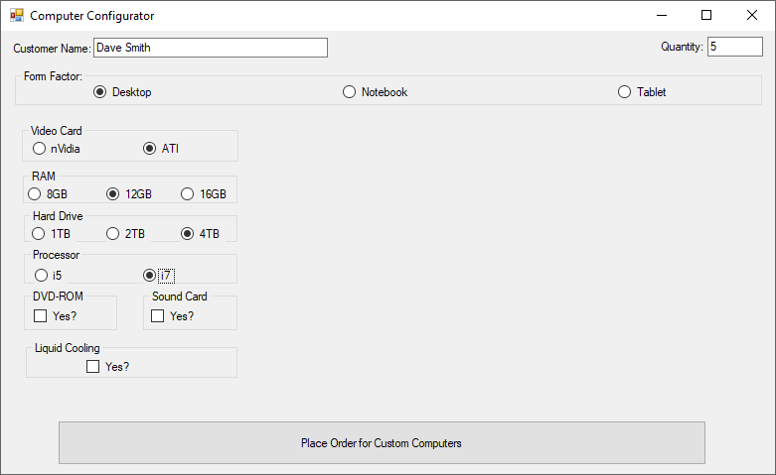

If the user tries to exit from the configuration screen, they will see the following message and then be returned back to the configuration screen:

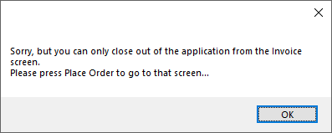

After the user has selected the desired options, the Place Order button will be pressed, taking them to the invoice screen. At the invoice screen, the cost of the computers and options will be displayed.

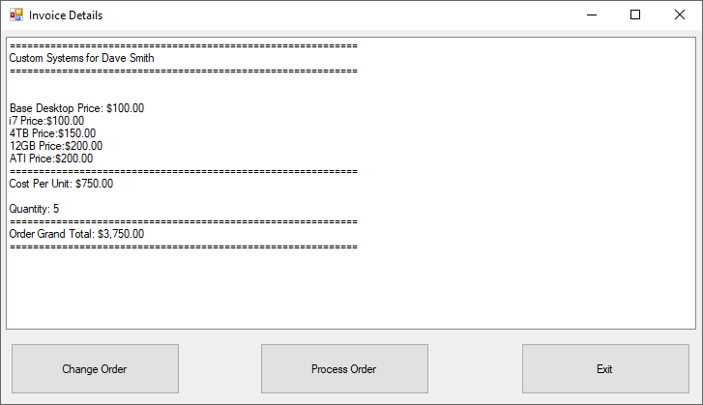

The user may (A) process the order (a messagebox is shown telling that the order has been sent to manufacturing and then the user is taken back to an empty configuration screen), (B) change the order (which will take the user back to the filled out configuration screen allowing changes) or (C) Exit the system (pressing the Exit button or clicking on the “X” in the upper right will both prompt the user if he/she is sure that they would like to quit the program).

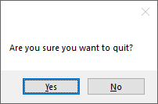

If the user exits and answers “yes” to the prompt, the program will terminate; “no” will go back to the invoice screen.

A couple of things to think about: (1) there is no calculate button on the invoice – as soon as it is shown the values are displayed and totals are automatically calculated. You cannot use the Load handler since it will only execute the first time the form is loaded, not each time when the forms are jumped between. (2) Since the user exits on the invoice screen, you will still have the original form running but hidden – you’ll need to figure out how to stop the original form at that point to actually get the application to stop running. Have fun and think about how to have the forms interact!

Complete your assignment and place your entire solution in a zip file, which you will upload to Canvas. Turn in a cover sheet and screenshots of your program’s execution stapled together in that order in class.